**1.** **Program to initialize an integer array and print the sum and average of the array.**

import java.util.*;

class Main{

public static void main(String[] args){

int n, sum = 0;

float average;

Scanner in = new Scanner(System.in);

System.out.print("Enter no. of elements you want in array: ");

n = in.nextInt();

int a[] = new int[n];

System.out.println("Enter all the elements: ");

for(int i = 0; i < n ; i++)

{

a[i] = in.nextInt();

sum = sum + a[i];

}

System.out.println("Sum:"+sum);

average = (float)sum / n;

System.out.println("Average:"+average);

}

}

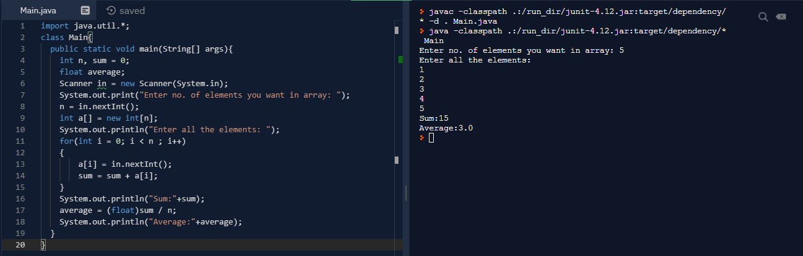

**2.** **Program to initialize an integer array and find the maximum and minimum value of an array.**

import java.util.*;

class Main{

public static void main(String[] args){

int n;

Scanner in = new Scanner(System.in);

System.out.print("Enter no. of elements you want in array: ");

n = in.nextInt();

int a[] = new int[n];

System.out.println("Enter all the elements: ");

for(int i = 0; i < n ; i++)

{

a[i] = in.nextInt();

}

Arrays.sort(a);

System.out.println("Minimum = " + a[0]);

System.out.println("Maximum = " + a[n - 1]);

}

}

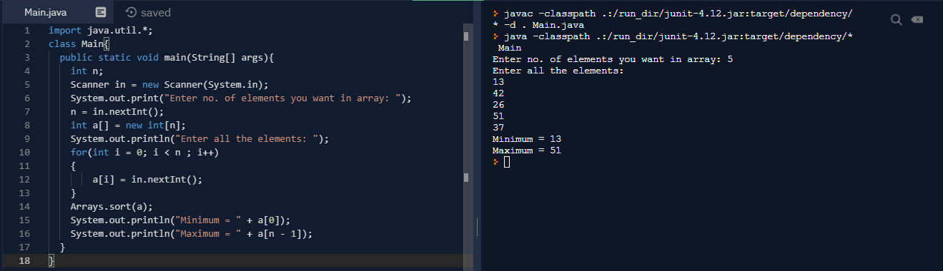

**3.** **Program to initialize an integer array with values and check if a given number is present in the array or not.**

import java.util.*;

class Main{

public static void main(String[] args){

Scanner in = new Scanner(System.in);

int s;

int a[] = {1,4,34,56,7};

System.out.println("Enter the element to search");

s = in.nextInt();

for(int i = 0; i < a.length; i++){

if(a[i] == s){

System.out.println(i + 1);

System.exit(0);

}

}

System.out.println(-1);

}

}

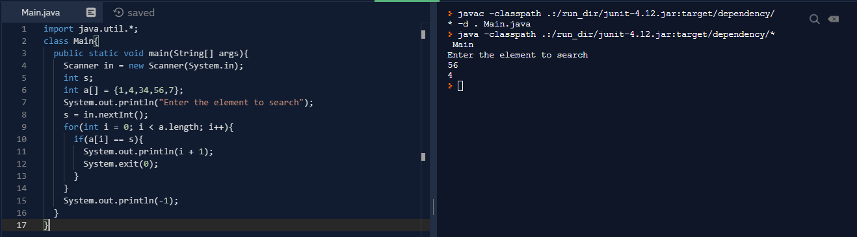

**4.Program to initialize an integer array with ascii values and print the corresponding character values in a single row.**

**5.** **Program to find the largest 2 numbers and the smallest 2 numbers in the given array.**

import java.util.*;

class Main{

public static void main(String[] args){

int n;

Scanner in = new Scanner(System.in);

System.out.print("Enter no. of elements you want in array: ");

n = in.nextInt();

int a[] = new int[n];

System.out.println("Enter all the elements: ");

for(int i = 0; i < n ; i++)

{

a[i] = in.nextInt();

}

Arrays.sort(a);

System.out.println("Smallest 2 elements = " + a[0] + ", " + a[1]);

System.out.println("Largest 2 elements = " + a[n-1] + ", " + a[n-2]);

}

}

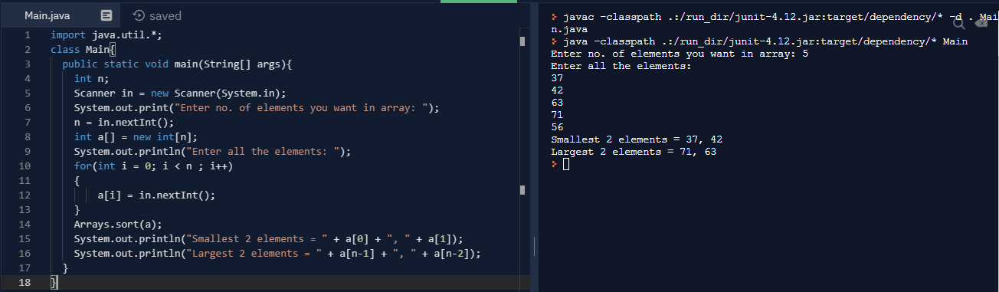

**6.Program to initialize an array and print them in a sorted fashion.**

import java.util.*;

class Main{

public static void main(String[] args){

int n;

Scanner in = new Scanner(System.in);

System.out.print("Enter no. of elements you want in array: ");

n = in.nextInt();

int a[] = new int[n];

System.out.println("Enter all the elements: ");

for(int i = 0; i < n ; i++)

{

a[i] = in.nextInt();

}

Arrays.sort(a);

System.out.println("The sorted array is: ");

for(int i = 0; i < n ; i++)

{

System.out.println(a[i]);

}

}

}

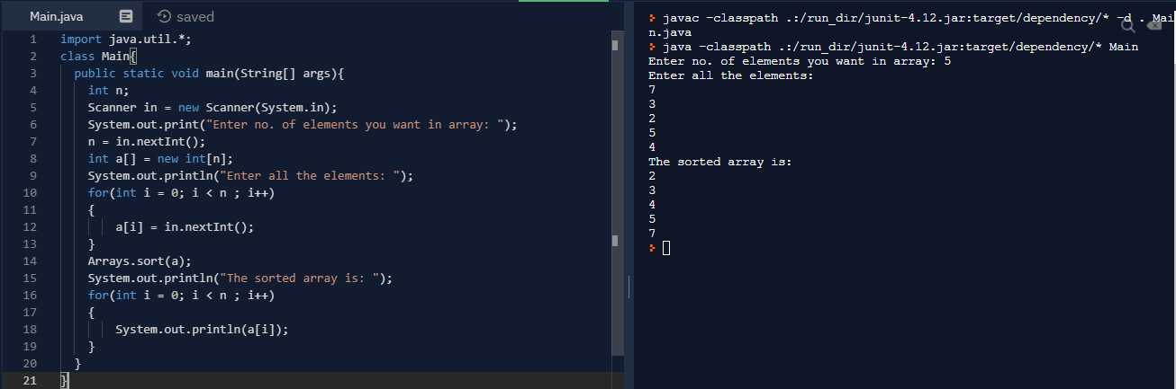

**7.** **Program to remove the duplicate elements in an array and print**

import java.util.*;

class Main{

static int removeDuplicates(int arr[], int n){

if (n == 0 || n == 1)

return n;

int j = 0;

for (int i = 0; i < n - 1; i++){

if (arr[i] != arr[i + 1])

arr[j++] = arr[i];

}

arr[j++] = arr[n - 1];

return j;

}

public static void main(String[] args){

int n;

Scanner in = new Scanner(System.in);

System.out.print("Enter no. of elements you want in array: ");

n = in.nextInt();

int a[] = new int[n];

System.out.println("Enter all the elements: ");

for(int i = 0; i < n ; i++){

a[i] = in.nextInt();

}

Arrays.sort(a);

int len = removeDuplicates(a, n);

System.out.println("Duplicates free array: ");

for(int i = 0; i < len ; i++){

System.out.println(a[i]);

}

}

}

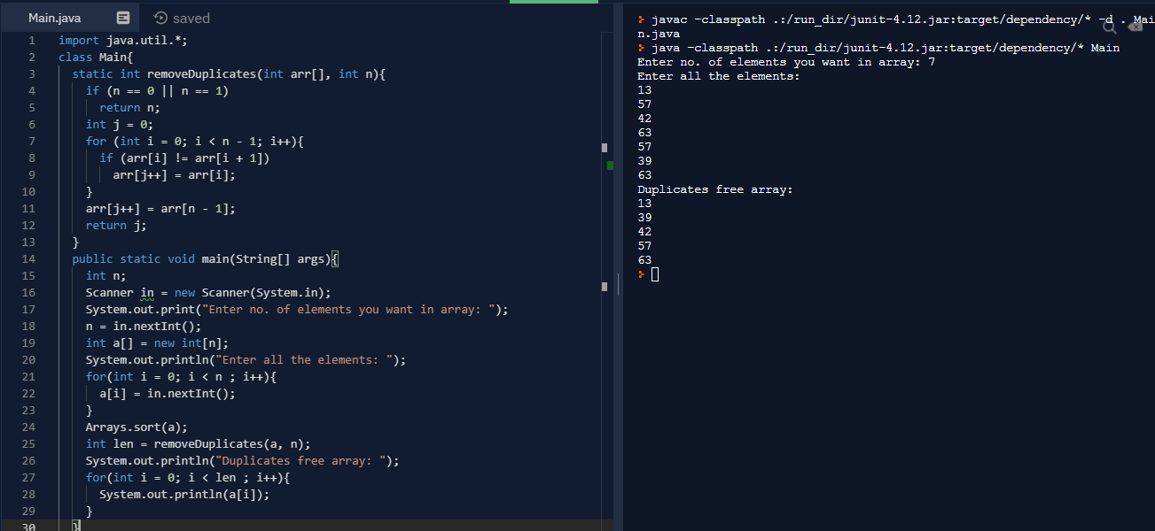

**8.** **Program to print the element of an array that has occurred the highest number of times.**

import java.util.*;

class Main{

static int mostFrequent(int arr[], int n){

Arrays.sort(arr);

int max_count = 1, res = arr[0];

int curr_count = 1;

for (int i = 1; i < n; i++){

if (arr[i] == arr[i - 1])

curr_count++;

else{

if (curr_count > max_count){

max_count = curr_count;

res = arr[i - 1];

}

curr_count = 1;

}

}

if (curr_count > max_count){

max_count = curr_count;

res = arr[n - 1];

}

return res;

}

public static void main(String[] args){

int n;

Scanner in = new Scanner(System.in);

System.out.print("Enter no. of elements you want in array: ");

n = in.nextInt();

int a[] = new int[n];

System.out.println("Enter all the elements: ");

for(int i = 0; i < n ; i++){

a[i] = in.nextInt();

}

System.out.println("Maximum repeating elemet in the array is: " + mostFrequent(a,n));

}

}

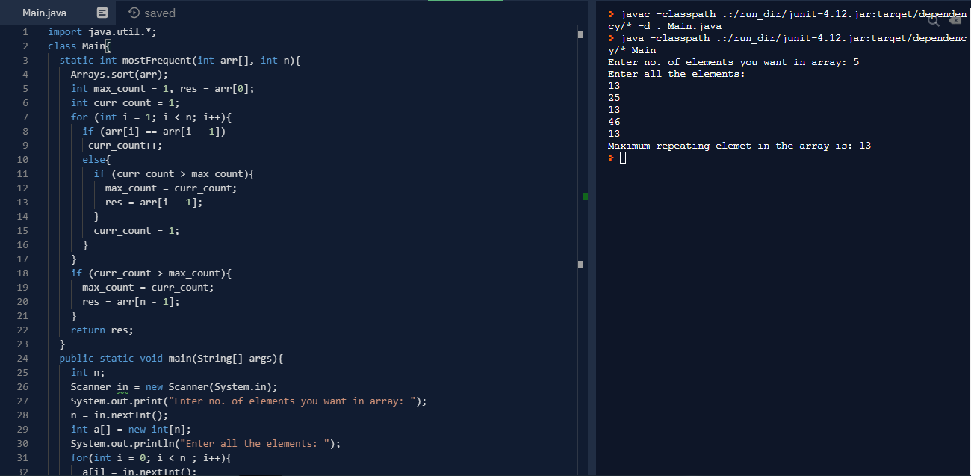

**9.** **Program to print the sum of the elements of the array with the given below condition. If the array has 6 and 7 in succeeding orders, ignore 6 and 7 and the numbers between them for the calculation of sum.**

import java.util.*;

class Main{

public static void main(String[] args){

int n, sum = 0;

Scanner in = new Scanner(System.in);

System.out.print("Enter no. of elements you want in array: ");

n = in.nextInt();

int a[] = new int[n];

System.out.println("Enter all the elements: ");

for(int i = 0; i < n ; i++){

a[i] = in.nextInt();

}

outer:

for (int i = 0; i < n; i++) {

if (a[i] == 6) {

for (int j = i + 1; j < n; j++) {

if (a[j] == 7) {

i = j;

continue outer;

}

}

}

sum += a[i];

}

System.out.println("The sum is " + sum);

}

}

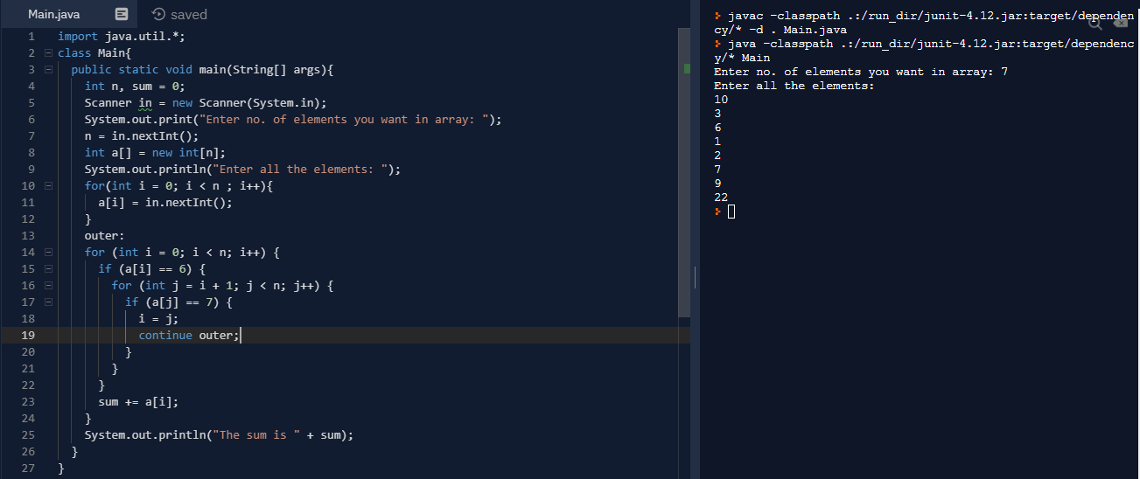

**10.** **Program to reverse the elements of a given 2*2 array. Four integer numbers needs to be passed as Command Line arguments.**

public class Main {

public static void main(String args[]){

int a=args.length;

int i;

int arr[][] = new int[4][4];

if(a<4)

System.out.println("enter 4 values");

if(a==4){

int k=0;

for(i=0;i<2;i++){

for(int j=0;j<2;j++){

arr[i][j]=Integer.parseInt(args[k]);

k++;

}

}

System.out.println("The given array is:");

for(i=0;i<2;i++){

for(int j=0;j<2;j++){

System.out.print(arr[i][j]+" ");

}

System.out.println();

}

System.out.println("The reverse of array is:");

for(i = 1;i >= 0; i--){

for(int j = 1; j >= 0; j--){

System.out.print(arr[i][j] + " ");

}

System.out.println();

}

}

}

}

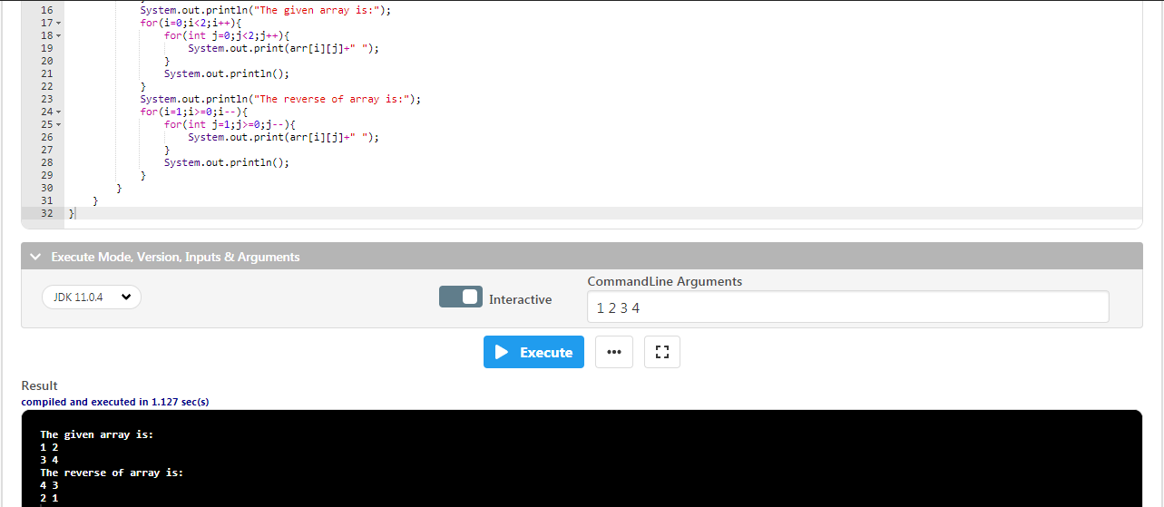

**11.** **Program to find greatest number in a 3*3 array. The program is supposed to receive 9 integer numbers as command line arguments.**

public class Main {

public static void main(String args[]){

int a=args.length;

int i;

int arr[][] = new int[4][4];

if(a<9)

System.out.println("enter 4 values");

if(a==9){

int k=0;

for(i=0;i<3;i++){

for(int j=0;j<3;j++){

arr[i][j]=Integer.parseInt(args[k]);

k++;

}

}

System.out.println("The given array is:");

for(i=0;i<3;i++){

for(int j=0;j<3;j++){

System.out.print(arr[i][j]+" ");

}

System.out.println();

}

int max = arr[0][0];

for(i = 2;i >= 0; i--){

for(int j = 2; j >= 0; j--){

if(arr[i][j] > max)

max = arr[i][j];

}

System.out.println();

}

System.out.println("The maximum element is:" + max);

}

}

}

